1. **Agenda:**
   1. How to consume messages from ActiveMQ.
2. 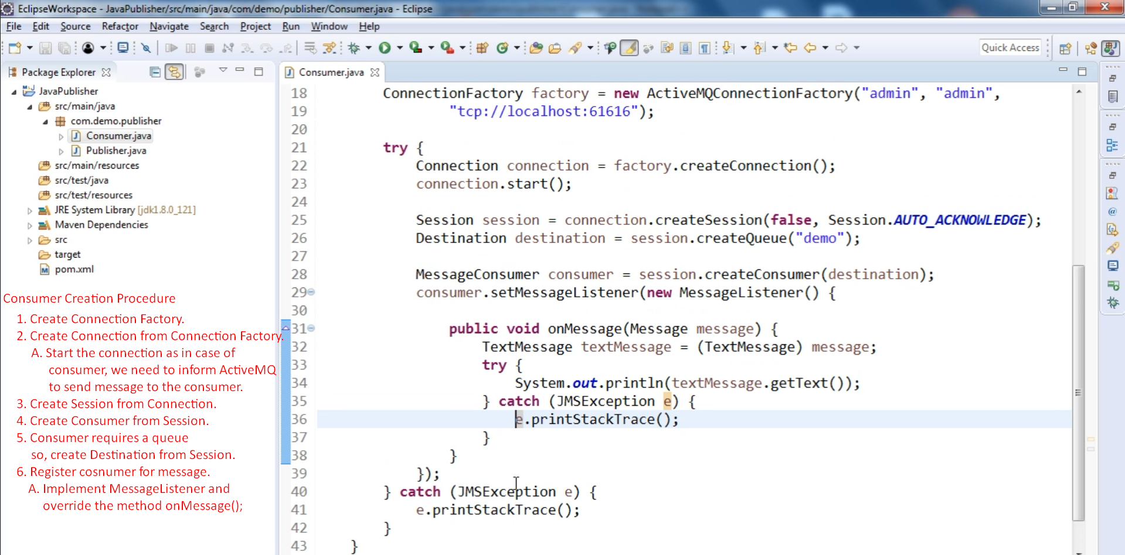  
   **NOTE**: MessageListener.**onMessage**(Message) will be called each time a msg is there in the queue.   
   **NOTE**: Consumer app will not step after consuming app automatically as it is required to listen constantly.
3. 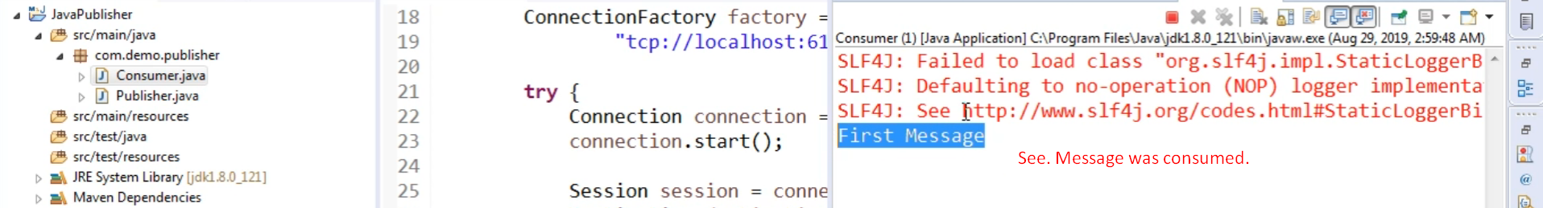
4. Graphical user interface, text, application

   Description automatically generated